**4HNE**

The results of the two-way ANOVA indicate that neither mouse type nor age (in months) has a statistically significant effect on 4HNE expression. The p-values for both mouse type (p = 0.286) and age (p = 1) are well above the common significance threshold (α= .05), suggesting that variations in these factors do not lead to meaningful differences in 4HNE expression. Additionally, the interaction between mouse type and age is not significant (p = 0.924), implying that the effect of one factor does not depend on the level of the other.

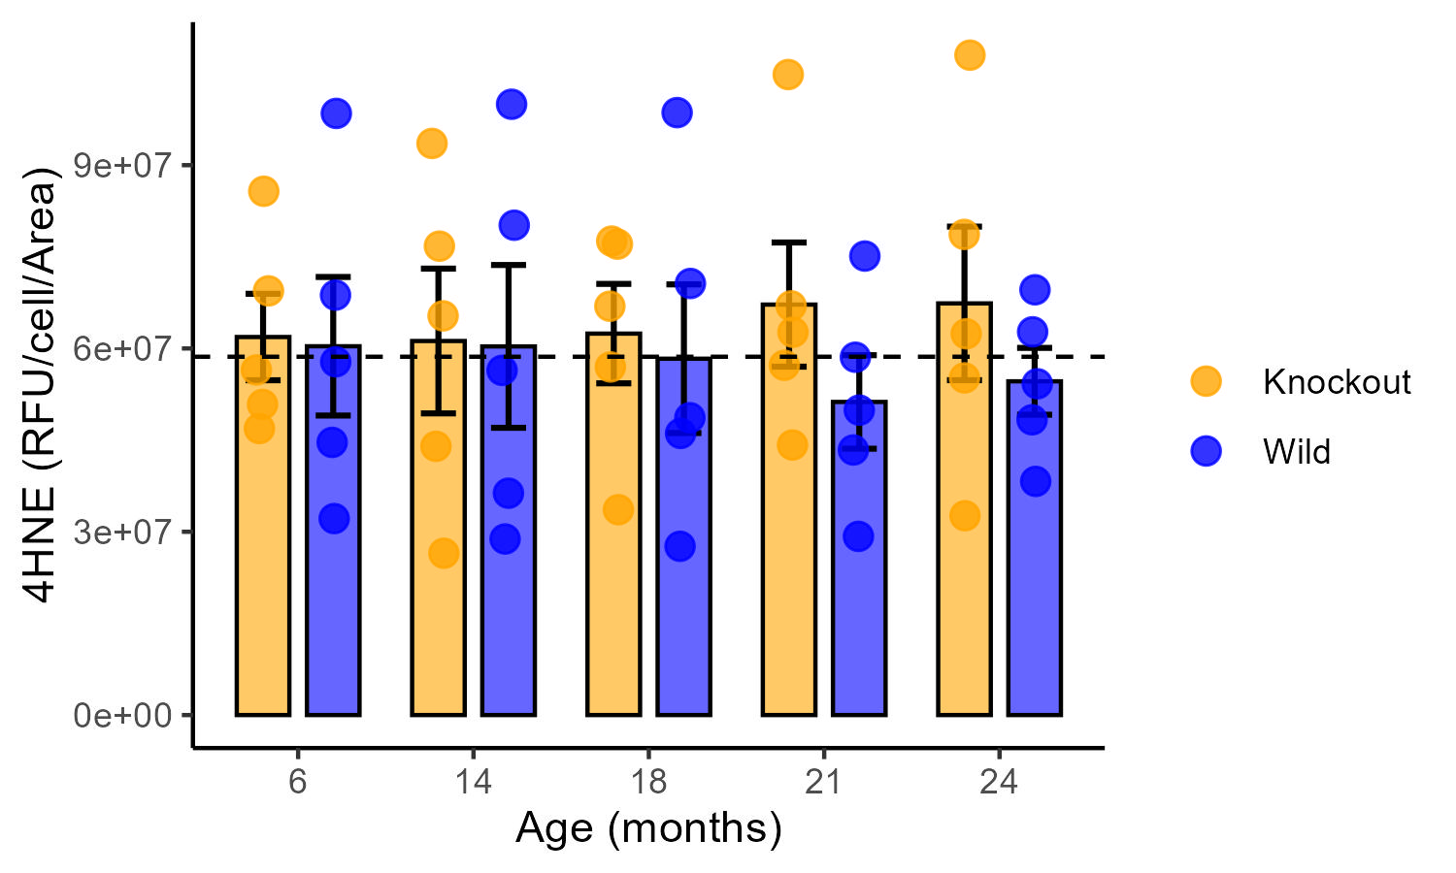

Figure 2: double column-bar chart with error bar. Bar represents the mean 4HNE expression; error bar represents the standard error of mean; Broken dashed line represents the mean male V4HNE (58644570).

Table 1: Summary statistics of 4HNE expression

|  |  |  |  |  |  |  |  |  |
| --- | --- | --- | --- | --- | --- | --- | --- | --- |
|  | Mean | std | se | Min | Max | Q25 | Q50 | Q75 |
| Knockout:14 | 61219328 | 26492604 | 10297691 | 26483798 | 93555311 | 43977559 | 65335150 | 76744819 |
| Knockout:18 | 62428949 | 18195750 | 10297691 | 33608113 | 77571271 | 56974567 | 66914720 | 77076077 |
| Knockout:21 | 67179507 | 22721243 | 10297691 | 44199328 | 1.05E+08 | 57242531 | 62655954 | 66968120 |
| Knockout:24 | 67374500 | 28103936 | 10297691 | 32624813 | 1.08E+08 | 55176859 | 62402986 | 78662474 |
| Knockout:6 | 61872082 | 15822713 | 10297691 | 46888976 | 85728741 | 50843131 | 56475264 | 69424295 |
| Wild :14 | 60335721 | 29791278 | 10297691 | 28817599 | 99966746 | 36309921 | 56413164 | 80171176 |
| Wild :18 | 58321445 | 27200691 | 10297691 | 27618434 | 98600362 | 46093279 | 48661241 | 70633909 |
| Wild :21 | 51244553 | 17113450 | 10297691 | 29241954 | 75123093 | 43383152 | 49909049 | 58565515 |
| Wild :24 | 54623177 | 12228773 | 10297691 | 38242528 | 69602672 | 48323537 | 54223626 | 62723520 |
| Wild :6 | 60359996 | 25355934 | 10297691 | 32157362 | 98468682 | 44627464 | 57816748 | 68729723 |

**VDAC**

The two-way ANOVA results show that neither mouse type nor age (in months) significantly influences VDAC expression, as indicated by the p-values for mouse type (p = 0.181) and age (p = 0.769), which are both above the common significance threshold (α= .05). Additionally, the interaction between mouse type and age is not significant (p = 0.928), suggesting that the effect of one factor does not depend on the level of the other.

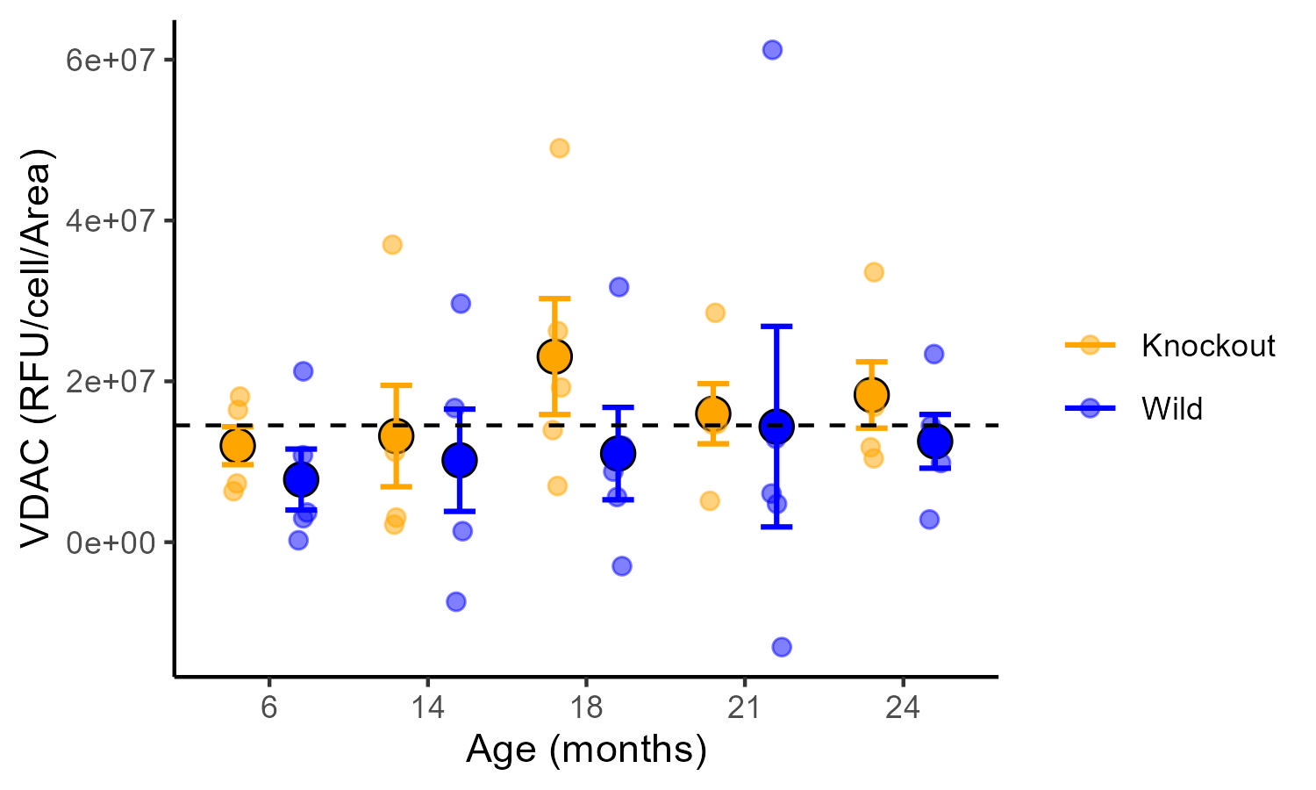

Figure 2: Scatter-dot chat with error bar. The large dot represents the mean; Error bar represents the standard error of mean; dashed line represent the average male VDAC (14524611).

Table 2: summary statistics of the VDAC expression data

|  |  |  |  |  |  |  |  |  |
| --- | --- | --- | --- | --- | --- | --- | --- | --- |
|  | Mean | std | se | Min | Max | Q25 | Q50 | Q75 |
| Knockout:14 | 13194087 | 14091066 | 6186099 | 2184589 | 36988298 | 3066074 | 11252016 | 12479458 |
| Knockout:18 | 23081932 | 16115390 | 6186099 | 6990985 | 48993371 | 13931506 | 19243535 | 26250265 |
| Knockout:21 | 15968978 | 8353637 | 6186099 | 5129044 | 28520715 | 14637765 | 14720816 | 16836552 |
| Knockout:24 | 18303098 | 9220189 | 6186099 | 10422853 | 33572776 | 11798333 | 16840242 | 18881289 |
| Knockout:6 | 11993487 | 5278138 | 6186099 | 6332109 | 18110603 | 7296445 | 11778746 | 16449531 |
| Wild :14 | 10186640 | 14224388 | 6186099 | -7411853 | 29666626 | 1366036 | 10633168 | 16679224 |
| Wild :18 | 11017513 | 12845516 | 6186099 | -2981916 | 31728243 | 5611944 | 8777487 | 11951804 |
| Wild :21 | 14365889 | 27883818 | 6186099 | -1.3E+07 | 61214624 | 4753339 | 6050694 | 12856645 |
| Wild :24 | 12538761 | 7470995 | 6186099 | 2821608 | 23386147 | 9850671 | 12148297 | 14487079 |
| Wild :6 | 7787624 | 8474072 | 6186099 | 231103.2 | 21241967 | 2972029 | 3686760 | 10806259 |